**Robotic Mapping**

Two basic concepts:

metric & topological representation

*(Coordinate-based representation). Coordinate-based representations express spatial relations between basic entities implicitly by providing coordinates for each of the spatial objects within a single absolute coordinate system.*

*(Relational representation). Relational representations express spatial relations b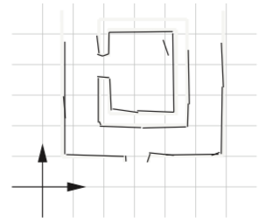etween basic entities by explicitly stating that a certain relation holds be- tween a certain set of objects.*

Coordinate-based representation - some examples

**Occupancy-Based Grid Map**

* doesn’t scale well in too large environments

|  |  |  |  |  |  |  |  |  |  |
| --- | --- | --- | --- | --- | --- | --- | --- | --- | --- |
| **border** | **border** | **border** | **border** | **border** | **border** | **border** | **border** | **border** | **border** |
| **border** |  | circle | circle |  |  |  |  |  | **border** |
| **border** | circle | **one** | **one** | circle |  |  |  |  | **border** |
| **border** | circle | **one** | **one** | circle |  |  |  |  | **border** |
| **border** |  | circle | circle |  |  |  |  |  | **border** |
| **border** |  |  |  |  |  |  |  |  | **border** |
| **border** |  |  |  |  |  |  |  |  | **border** |
| **border** |  |  |  |  |  |  |  |  | **border** |
| **border** |  |  |  |  |  |  |  |  | **border** |
| **border** |  |  |  |  |  |  |  |  | **border** |
| **border** | **border** | **border** | **border** | **border** | **border** | **border** | **border** | **border** | **border** |

**Geometric Representations**

Geometric representations use parameterized primitive geometric objects, i.e., points, lines, curves, planes, etc.

Data Structure

Goal

* the goal is to identify objects and build a map

How to get there

* to identify objects we detect shapes
* we build a map by placing the objects | shapes in a coordinate space

Possible basic objects

* Map: Grid with Shapes
* Grid
* Shape: (circle, border, etc.)